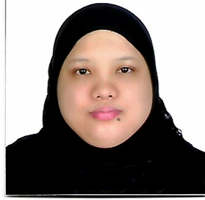**Geraldine R. Macasero**

**Al Gudaibiya, Manama Bahrain**

**Email:** [**applemacasero@yahoo.com**](mailto:applemacasero@yahoo.com)

**Mobile no. +973 66606762**

**Personal Data:**

Date of Birth: December 30, 1979

Place of Birth: Cebu, Philippines

Nationality: Filipino

Visa Status: Under Company

**Work Experience:**

* Femi9/Bcc – Sales Associate/Assistant Manager – From October 2008 up to January 2020
* Exclusive Boutique/ Al Ali Mall – Saleslady From March 2008 to October 2008
* Maya Pastries/ Salmaniya- Cashier From May 2007 to July 2007
* Veranda café Gallery/ Al Adliya – Waitress From July 2006 to January 2007 ( December’s Employee of the Month)

**Key Skills:**

* Resourceful
* Active Listening
* Communication
* Conflict Resolution
* Critical Thinking
* Customer Services
* Decision Making
* Leadership
* Problem Solving
* Teamwork
* Ability to Work Under Pressure
* Time Management
* Efficient
* Affectionate
* Multi Tasking

**Key Job Skills**

* Data Entry
* Answering Phones
* Billing
* Scheduling
* Merchandising
* Property Custodian
* Shipping/logistics
* Product Knowledge
* Customer Needs Analysis
* POS Skills
* Cashier Skills
* Sales Report
* Stock Take Report
* Bulk Messaging
* Cash Deposits
* Miscellaneous Purchaser

**Academic Skills**:

• Bachelor of Science in Computer Science- Undergraduate

• Computer Literate-MS Office

**Communication Skills**:

• Filipino – Mother tongue

• English – Fluent

• Arabic – Basic

I do hereby confirm that the above mention particulars furnished by me are **TRUE** and **ACCURATE** to thebest of my knowledge.

**Geraldine Rodriguez Macasero**